Control charts for attributes mainly differ from the previous examples in that we need to provide sample sizes through the size argument.

|  |
| --- |
| **Orangejuice Data set**  Frozen orange juice concentrate is packed in 6-oz cardboard cans. These cans are formed on a machine by spinning them from cardboard stock and attaching a metal bottom panel. A can is then inspected to determine whether, when filled, the liquid could possible leak either on the side seam or around the bottom joint. If this occurs a can is considered nonconforming.  The data were collected as 30 samples of 50 cans each at half-hour intervals over a three-shift period in which the machine was in continuous operation.  From sample 15 used a new batch of cardboard stock was punt into production. Sample 23 was obtained when an inexperienced operator was temporarily assigned to the machine.  After the first 30 samples, a machine adjustment was made. Then further 24 samples were taken from the process. |

|  |
| --- |
| > orangejuice  sample D size trial  1 1 12 50 TRUE  2 2 15 50 TRUE  3 3 8 50 TRUE  …  …  30 30 6 50 TRUE  31 31 9 50 FALSE  32 32 6 50 FALSE  …  …  …  53 53 3 50 FALSE  54 54 5 50 FALSE |

|  |
| --- |
| Obj.A <- qcc(D[trial], sizes=size[trial], type="p") |

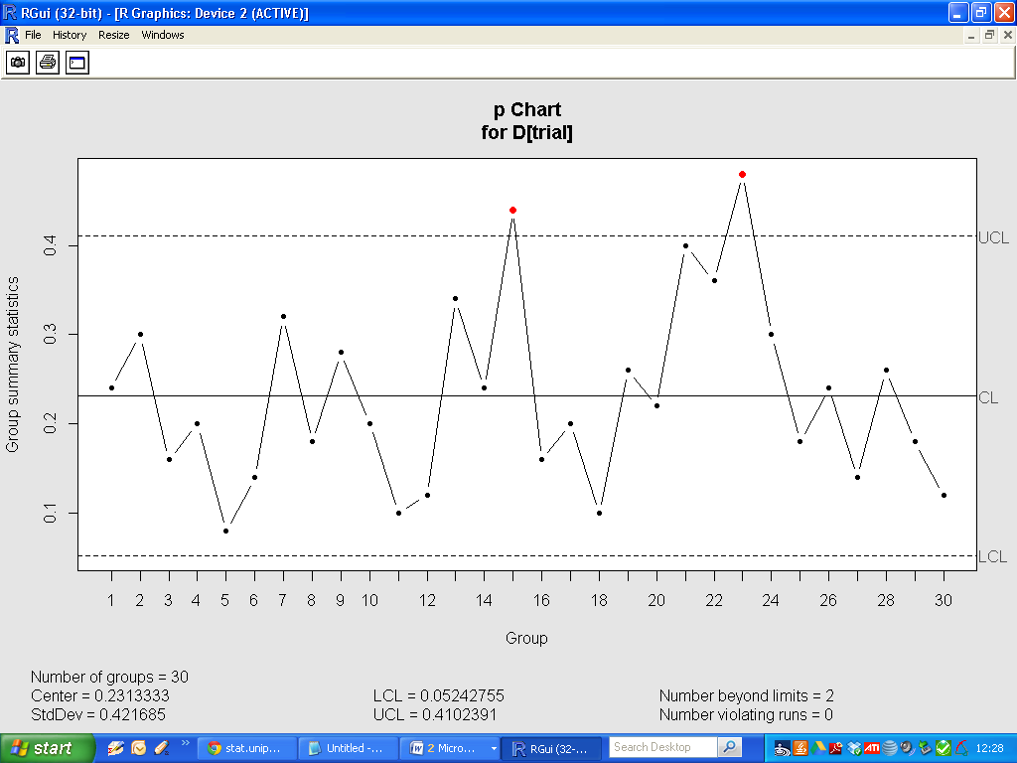

|  |
| --- |
| Obj.B <- qcc(D, sizes=size, type="p") |

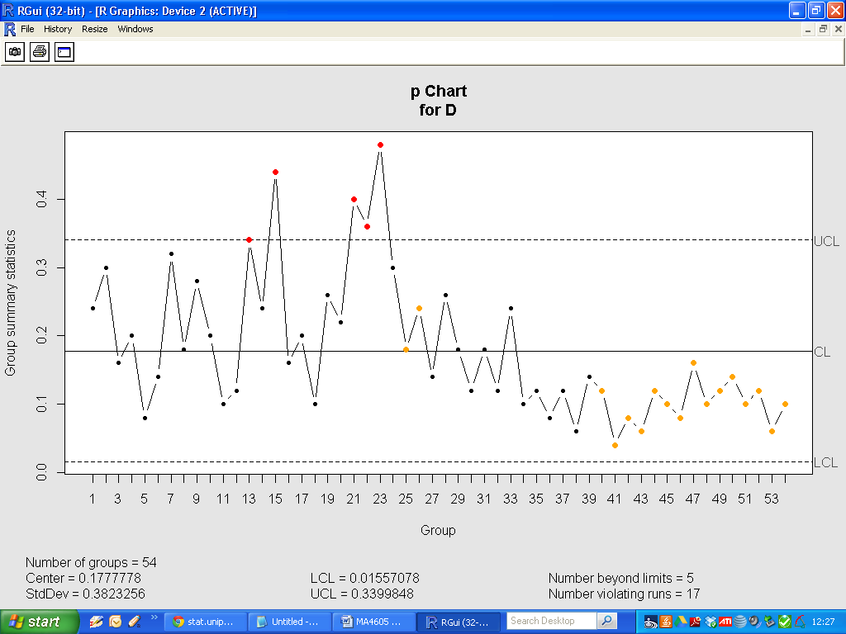

Operating characteristic function

An operating characteristic (OC) curve provides information about the probability of not detecting a shift in the process. This is usually referred to as the type II error, that is, the probability of erroneously accepting a process as being “in control”.